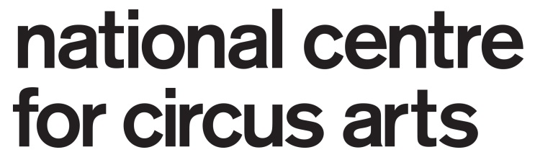

National Centre for Circus Arts Teacher

Role National Centre for Circus Arts Teacher
Contact
Support Director of Training
Programme Heads

Overall purpose of job
To be part of a working team on the delivery of a ‘best practice’ teaching system for the National Centre for Circus Arts.

Through the use of sound Learning and Teaching principles and reflective practice, this role will help us ensure the experience of the class participants at the National Centre aligns with the ethos and methodology of the organisation.
A National Centre teacher in this role is a valued staff member and an ambassador for the organisation.

This role as an integral part of our teaching team will allow us to bring a new consistency to circus delivery and permit us to move towards the elite standards of circus teaching that we set as our target as the National Centre.

You are required to:
- To develop and deliver your teaching practice in response to the varied learning objectives and teaching environments at the National Centre. This includes appropriate class planning.

- Contribute to the collective teaching plan for both short and long term learning targets and to help the class participants progressing within this system.

- Attend team meetings as required.

- Attend any training that is deemed suitable or essential for professional development. Identify your own training needs as they arise.

- Follow and enforce the National Centre Health and Safety and First Aid policies and procedures.

- Assume an overall responsibility for training space management during teaching sessions.

- Work with appropriate department teams to ensure the quality of delivery of all classes is at the highest possible standard.

- Be integral in communication between participants, teaching staff and administration staff.

- Be willing to exchange with and learn from colleagues.

Professional skills, knowledge and experience

Required
- Practical teaching experience at a professional level and the ability to work with students with various abilities/technical levels/experience.

- Ability to work enthusiastically within a team.

- Knowledge of ‘health’ in regards to posture, movement and training programme design.

- A knowledge of and interest in contemporary circus and or physical/visual performance.

- An open attitude to your own continuing professional development and to new ways of working.

- Strong inter-personal skills and an ability to support through positive feedback.

Desired

- Experience as a circus professional.

Person Specification

Essential

- The ability to inspire participation, nurture learning and build long term relationships with class participants and teachers.

- Excellent interpersonal skills with an ability to communicate information effectively to a wide range of people

- Able to work in a busy work environment, including remaining calm and finding solutions when under pressure.

- An understanding of issues around keeping young and vulnerable people safe from harm

- An understanding of the physicality of the human body and how this translates to and influences ‘best practice’ for circus training.

- Knowledge of Health and Safety policies

