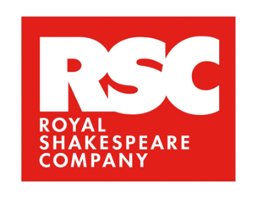
CASTING OPPORTUNITY

We are looking for an exceptional performer to play the role of Ariel in the Royal Shakespeare Company's forthcoming production of 'The Tempest’, directed by Sir Richard Eyre.
Where:
Rehearsals in London, UK
Performances in the Royal Shakespeare Theatre, Stratford upon Avon, UK
When: 23 March – 20 June 2026 (Monday – Saturday full-time; this is a paid opportunity)
Role characteristics & skills:
- Black African, Black Caribbean, or Black heritage from other areas.
- Female identifying.
- In this production Ariel flies throughout, appearing weightless. This performer could come from a dance background with strong physical skills, or a circus background.
- Skilled verse speaking and solo singing are also required for this role.
Context on the play and the role:
Ariel is a spirit with supernatural powers. Native to the island. Enslaved by Prospero, he uses her magic to his own ends whilst promising her freedom in return. Prospero will be played by Sir Kenneth Branagh. This is a principal acting role.
This production, set in 1610, will explore colonialism through the lens of Black histories and cultural perspectives, examining the power dynamic between a coloniser and the people and autonomy that the coloniser disrupts. The actor playing Ariel will portray a character whose experiences reflect the colonisation of their island, where the native population is of Black heritage. Because of this, we are looking for actors of Black heritage who can bring insight, integrity and care to the portrayal of the role. We are also interested in Ariel being female identifying, in order to explore how this identity shapes the character's relationship with Prospero and the Island's power structures.
We are committed to working closely with the performers to shape this role with accuracy, depth and care, ensuring the portrayal reflects cultural understanding and avoids any harmful stereotypes.
Applicants should be aged 18+ (no upper age limit), be based in the UK, and have the right to work here.

How to apply:
Please submit your CV, headshot, and a dance/aerial skills reel if you have one, to suggestions@rsc.org.uk with THE TEMPEST APPLICATION in the subject line.
Deadline for applications: Wednesday 01 October 2025
Auditions in London from w/c 29 September 2025

